Assignment-1

Domain: IOT

TOPIC: SMART WASTEGE

TEAM ID: **PNT2022TMID17404**

DATE:12/10/2022

COLLEGE: MAHENDRA INSTITUTE OF TECNOLOGY.

Circuit:

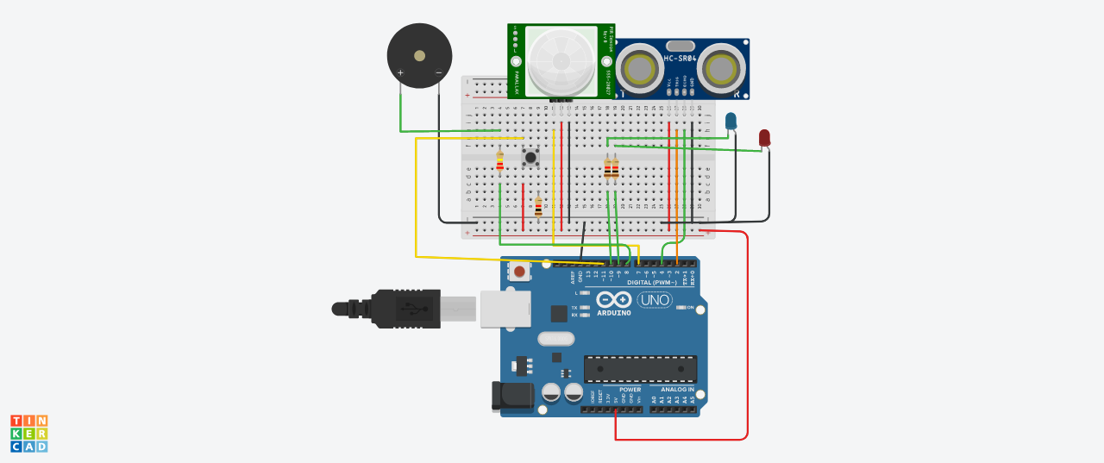

Code:

#define trigPin 7

#define echoPin 6

#define led 13

#define led2 12

#define led3 11

#define led4 10

#define led5 9

#define led6 8

#define buzzer 3

int sound = 250;

void setup() {

Serial.begin (9600);

pinMode(trigPin, OUTPUT);

pinMode(echoPin, INPUT);

pinMode(led, OUTPUT);

pinMode(led2, OUTPUT);

pinMode(led3, OUTPUT);

pinMode(led4, OUTPUT);

pinMode(led5, OUTPUT);

pinMode(led6, OUTPUT);

pinMode(buzzer, OUTPUT);

}

void loop() {

long duration, distance;

digitalWrite(trigPin, LOW);

delayMicroseconds(2);

digitalWrite(trigPin, HIGH);

delayMicroseconds(10);

digitalWrite(trigPin, LOW);

duration = pulseIn(echoPin, HIGH);

distance = (duration/2) / 29.1;

if (distance <= 30) {

digitalWrite(led, HIGH);

sound = 250;

}

else {

digitalWrite(led,LOW);

}

if (distance < 25) {

digitalWrite(led2, HIGH);

sound = 260;

}

else {

digitalWrite(led2, LOW);

}

if (distance < 20) {

digitalWrite(led3, HIGH);

sound = 270;

}

else {

digitalWrite(led3, LOW);

}

if (distance < 15) {

digitalWrite(led4, HIGH);

sound = 280;

}

else {

digitalWrite(led4,LOW);

}

if (distance < 10) {

digitalWrite(led5, HIGH);

sound = 290;

}

else {

digitalWrite(led5,LOW);

}

if (distance < 5) {

digitalWrite(led6, HIGH);

sound = 300;

}

else {

digitalWrite(led6,LOW);

}

if (distance > 30 || distance <= 0){

Serial.println("Out of range");

noTone(buzzer);

}

else {

Serial.print(distance);

Serial.println(" cm");

tone(buzzer, sound);

}

delay(500);